CANB Grant Program

Preservation and Conservation

Application

2022 – 2023

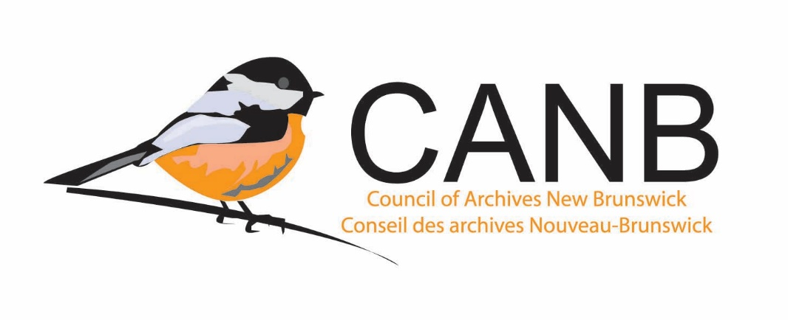

Application Form

1.0 General Information
Name of Organisation

Project Lead

Phone Number

Email Address

Civic Address

Website

  - Is your institution’s Mission Statement and / or Mandate on file with CANB?
- Yes
- No
- It’s been updated and resubmitted.

  - Was this application reviewed by and / or discussed with the Archives Advisor?
- Yes
- No

2.0 Project Proposal
Project Title

Proposed Start Date

Proposed Completion Date

2.1 Describe the project:
- Describe the records involved in the proposed project: fonds / collection name, source of acquisition, dates, physical extent (expressed in cm or m), type of records (textual, photographic, cartographic / architectural, and / or sound recording and moving images), etc.
- What type of preservation/conservation treatment will be carried out on the records?
- How will the records benefit from the preservation/conservation treatment?
- Who are your project partners? (If applicable)

2.2 Is the preservation/conservation work being carried out by the PANB Conservation Lab?
___ Yes
___ No

2.2.1 If yes, have you spoken to the PANB Conservation Lab about the project?
___ Yes
___ No

2.2.2 If no, who will be carrying out the preservation/conservation treatment? Why were they chosen over the PANB Conservation Lab? Is the person carrying out the preservation/conservation treatment a trained and certified conservator?

3.0 Budget
Total cost of the project

Amount from project partners (if applicable)

Amount to be covered by your institution

Amount requested from CANB

4.0 Other Information
4.1 Is there anything else your institution wishes the Adjudication Committee to know about regarding this application?

